Họ và tên: Ngô Chí Thuận

MSSV: 523H0102

HOẠT ĐỘNG 1 (Lab 1.1)

1a/ Điền bản chân trị:

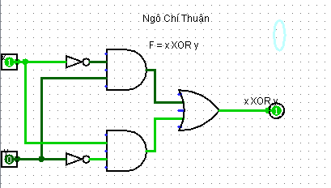

|  |  |  |
| --- | --- | --- |
| x | y | F = x XOR y |
| 0 | 0 | 0 |
| 0 | 1 | 1 |
| 1 | 0 | 1 |
| 1 | 1 | 0 |

HOẠT ĐỘNG 2 (Lab 1.2)

|  |  |  |  |
| --- | --- | --- | --- |
| x | y | z | F3 |
| 0 | 0 | 0 | 0 |
| 0 | 0 | 1 | 1 |
| 0 | 1 | 0 | 0 |
| 0 | 1 | 1 | 1 |
| 1 | 0 | 0 | 1 |
| 1 | 0 | 1 | 1 |
| 1 | 1 | 0 | 1 |
| 1 | 1 | 1 | 0 |

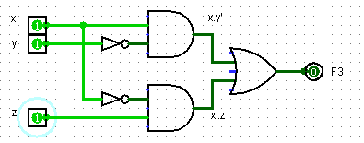

Yêu cầu 3:

2a/ ABC + AB + ABC

|  |  |  |  |
| --- | --- | --- | --- |
| A | B | C | Fa = ABC + AB + ABC |
| 0 | 0 | 0 | 0 |
| 0 | 0 | 1 | 0 |
| 0 | 1 | 0 | 0 |
| 0 | 1 | 1 | 0 |
| 1 | 0 | 0 | 0 |
| 1 | 0 | 1 | 0 |
| 1 | 1 | 0 | 1 |
| 1 | 1 | 1 | 1 |

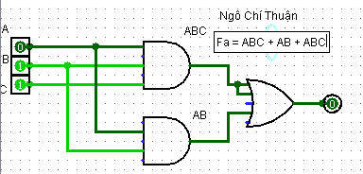

2b/ xyz + xz

|  |  |  |  |
| --- | --- | --- | --- |
| x | y | z | xyz + xz |
| 0 | 0 | 0 | 0 |
| 0 | 0 | 1 | 0 |
| 0 | 1 | 0 | 0 |
| 0 | 1 | 1 | 0 |
| 1 | 0 | 0 | 0 |
| 1 | 0 | 1 | 1 |
| 1 | 1 | 0 | 0 |
| 1 | 1 | 1 | 1 |

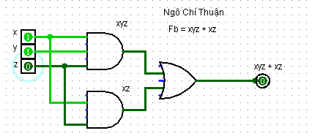

2c/ (x + y)(x + y)

|  |  |  |
| --- | --- | --- |
| x | y | Fc = (x + y)(x + y) |
| 0 | 0 | 0 |
| 0 | 1 | 1 |
| 1 | 0 | 1 |
| 1 | 1 | 1 |

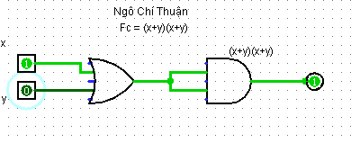

2d/ xy + x(wz + wz)

|  |  |  |  |  |
| --- | --- | --- | --- | --- |
| x | y | z | w | Fd = xy + x(wz + wz) |
| 0 | 0 | 0 | 0 | 0 |
| 0 | 0 | 0 | 1 | 0 |
| 0 | 0 | 1 | 0 | 0 |
| 0 | 0 | 1 | 1 | 0 |
| 0 | 1 | 0 | 0 | 0 |
| 0 | 1 | 0 | 1 | 0 |
| 0 | 1 | 1 | 0 | 0 |
| 0 | 1 | 1 | 1 | 1 |
| 1 | 0 | 0 | 0 | 0 |
| 1 | 0 | 0 | 1 | 0 |
| 1 | 0 | 1 | 0 | 0 |
| 1 | 0 | 1 | 1 | 0 |
| 1 | 1 | 0 | 0 | 1 |
| 1 | 1 | 0 | 1 | 1 |
| 1 | 1 | 1 | 0 | 1 |
| 1 | 1 | 1 | 1 | 1 |

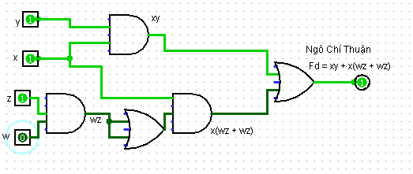

2e/ (BC + AD) (AB + CD)

|  |  |  |  |  |
| --- | --- | --- | --- | --- |
| A | B | C | D | Fe = (BC + AD) (AB + CD) |
| 0 | 0 | 0 | 0 | 0 |
| 0 | 0 | 0 | 1 | 0 |
| 0 | 0 | 1 | 0 | 0 |
| 0 | 0 | 1 | 1 | 0 |
| 0 | 1 | 0 | 0 | 0 |
| 0 | 1 | 0 | 1 | 0 |
| 0 | 1 | 1 | 0 | 0 |
| 0 | 1 | 1 | 1 | 1 |
| 1 | 0 | 0 | 0 | 0 |
| 1 | 0 | 0 | 1 | 0 |
| 1 | 0 | 1 | 0 | 0 |
| 1 | 0 | 1 | 1 | 1 |
| 1 | 1 | 0 | 0 | 0 |
| 1 | 1 | 0 | 1 | 1 |
| 1 | 1 | 1 | 0 | 1 |
| 1 | 1 | 1 | 1 | 1 |

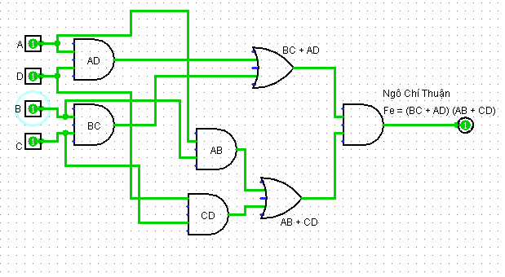

2f/ (a + c) (a + b + c)

|  |  |  |  |
| --- | --- | --- | --- |
| a | b | c | Ff = (a + c) (a + b + c) |
| 0 | 0 | 0 |  |
| 0 | 0 | 1 |  |
| 0 | 1 | 0 |  |
| 0 | 1 | 1 |  |
| 1 | 0 | 0 |  |
| 1 | 0 | 1 |  |
| 1 | 1 | 0 |  |
| 1 | 1 | 1 |  |